P003. Peetooloot 09.

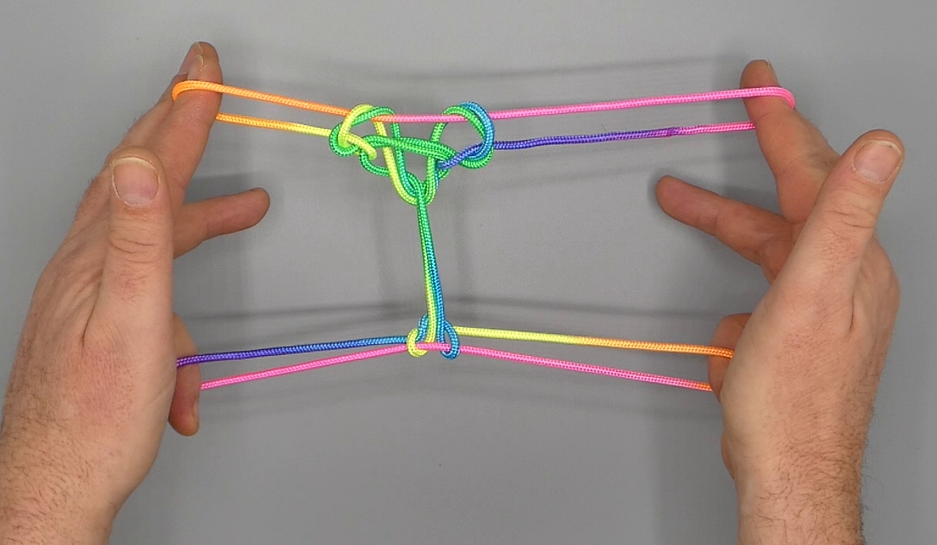

1. Opening A.
2. Pass 23 towards the body over all intermediate strings and trap 1n between the tips of 23 (2 passing over, 3 passing under 1n). Return by rotating 23 down, away from the body over all intermediate strings and up to create an upper 2 loop. Release 1 loop and separate 2 and 3.
3. Pass 1 under all intermediate strings from below in 5 loop and return with 5n and lower 2f.
4. With R1 over all intermediate strings pick up R5f. With L1 from below share upper R1 loop.
5. With tips of L12 grasp upper R2n (the string that runs through the figure to upper L1n) and pass it over the tip of R1; release grip of L12. With tips of R12 grasp upper L2n (the string that runs through the figure to upper R2n) close to L2 and pass it over tip of L1; release grip of R12.
6. Navajo 1 by passing tips of 1 towards each other, down towards the body under triple 1n and up.
7. Release 5 loop.
8. At the lower side of the figure, close to each hand a triangular shape can be discerned with a base running from upper 2f to 1n, and the sides pass under 2 loops and 1 loop. At the upper side of the figure is a near horizontal string which is a continuation of the string segment crossing the 1 loop. Pass 5 under all intermediate strings from below into its respective triangular shape then to the far side of the near horizontal string, and hook down this near horizontal string through the triangular shape, closing 5 to the palm.
9. Pass L12 over the figure from above in upper R2 loop and grasp lower R2n, then remove lower R2 loop through upper R2 loop from R2 by pulling R2n string upwards. Pass R2 towards the body in the loop running from the tips of L12 towards the RH and release grip of L12. The former lower R2 loop now has been untwisted and replaced on R2.
10. Movement 8 with R12 on LH.
11. Pass 3 from below in double 2 loop close to 2, then pass 23 over the figure towards the body and trap 1n between the tips of 23 close to 1 (2 passing over, 3 passing under 1n). Return by rotating 23 down, away from the body over all intermediate strings through double 2 loop (which slips off 2) and up to create a new 2 loop. Release 1 loop and separate 2 and 3. Extend with palms facing each other, 2 pointing up and away from the body, 5 being crooked.
12. At the near side of the figure two vertical string segments can be discerned, which are strung up between TV 2n and TV 5f. With 1 towards the center pick up respective vertical string segment.
13. With R1 from below remove L1 loop; with L1 from below share double R1 loop. With 1 pick up 2n. Navajo 1 by passing tips of 1 towards each other over upper 1n, then down towards the body under middle and lower 1n and up. Release 2 loop.
14. Each 1 loop is crossed by a single crossing string and by a double crossing string. Starting from the L1 loop and following it from left to right the double crossing string passes from the near to the far side over TV 1n and continues through the figure, then passes from the far to the near side over TV 1n close to R1. Directly below TV 1n the double crossing string forms a double string space. Pass 23 from the far side towards the body into respective double string space, then trap TV 1n between the tips of 23 (2 passing over, 3 passing under 1n). Return by rotating 23 down, away from the body through the double string space and up to create a new 2 loop. Release 1 loop and separate 2 and 3.
15. Extend, palms facing each other, 2 pointing away from the body, 5 being crooked.

