P032. Peetooloot 8.

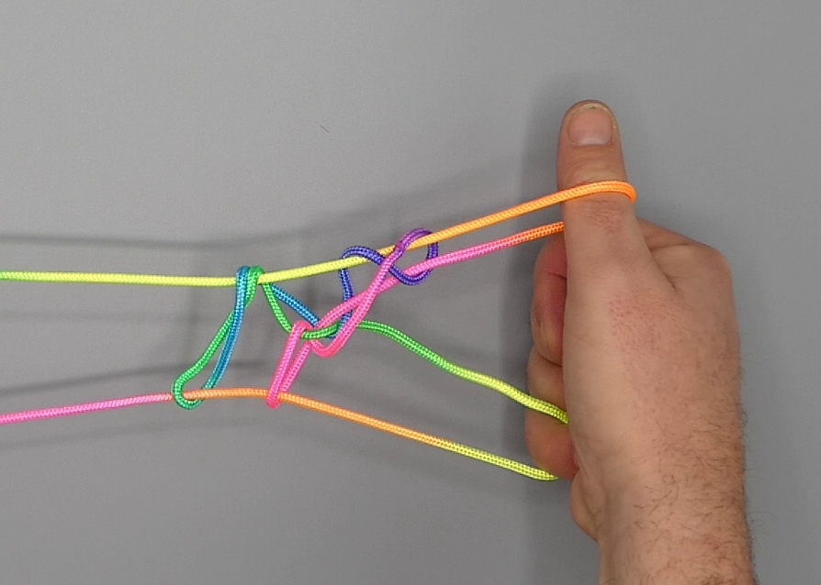

1. Hold hands with palms facing each other, fingers pointing away from the body. Place an untwisted loop over 1 so that there is a short TV 1n, and allow 1f to hang down between the hands. Close 45 to the palm over the palmar string segment.
2. Bring 2 towards the body over 1n, then with 2 hook up 1n by turning 2 down, away from the body and up.
3. With R1 pick up L1n –L2f string segment. With L1, under R1f –L2f string segment, pick up R1n – R2f string segment close to R1 (making sure to keep the original L1n on L1).
4. Extend to absorb the slack as 45 is removed from the figure.
5. Pass 5 from below in lower 1 loop only, picking up TV 1f.
6. Pass L5 (under L2 loop) to the far side of L2f and with L5 hook down L2f through the original L5 loop, closing L5 to the palm. Simultaneously pass R5 to far side of upper R1f and hook down upper R1f through lower R1 loop, closing R5 to the palm.
7. There are two loops on 1. With 1 hook the 1f that passes obliquely toward the middle of the figure while allowing the other 1 loop to slip off 1. Upright 1.
8. Extend the figure, palms facing each other, 1 pointing upwards, 2 pointing away from the body, 5 being crooked.
9. With 2 from above remove 1 loop, allowing the original 1 loop to slip over original 2 loop to become a lower 2 loop.
10. With 1 pick up upper 2n.
11. Release 2 loops.
12. With 2 hook up 1n in the following way: Bring 23 over intermediate strings towards the body and pinch 1n between tips of 23, 2 passing at the near side, 3 at the far side of 1n. Turn 23 away from the body over intermediate strings and up, and separate 2 and 3. Release 1 loop.
13. With L1 from the near side and from the left pick up the string segment crossing the L5 loop at the near side of the figure, and with R1 from the near side and from the right pick up the string segment crossing R5n and R2n at the near side of the figure.
14. With 2 from above remove 1 loop, allowing the original 1 loop to slip over original 2 loop to become a lower 2 loop.
15. With 1 pick up upper 2n and release 2 loops.
16. Pass L2 from below (= towards the body) into L5 loop, then from below in L1 loop, and hook up L1n by passing L2 towards the body over L1n, down, away from the body through L5 loop and up.
17. Release L1 and L5 loop, then with L345 from above share L2 loop and pull down L2f, closing L345 to the palm. Gently extend, palms facing each other, L2 pointing away from the body, R1 pointing upwards, L345 and R5 being crooked.

