P042a. Peetooloot 01
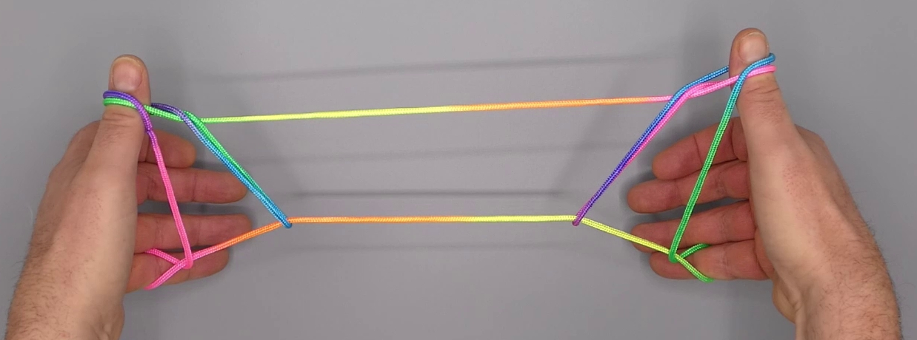
1. Opening A.
2. Pass 1 over 1f and under all intermediate strings to the far side of 5f, pick up 5f then return 1 under 5n to the near side of 5n.
3. Pass 1 away from the body over 5n, down under all intermediate strings towards the body and up.
4. Release 2 loop and extend, palms facing each other, 1 pointing upwards, 5 pointing towards the floor.

