P044. Kitikmeot 11

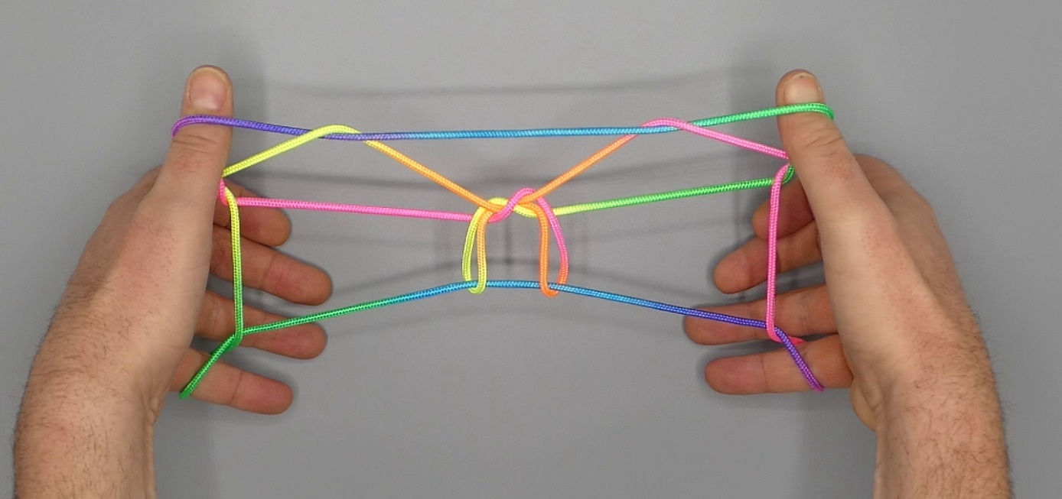

1. Opening A.
2. Pass 2 away from the body, over all strings, around 5f, then towards the body under all intermediate strings, and insert 2 from below into 1 loop. Hook up 1n with 2 by retracing its path.
3. Release 1 loop.
4. Pass 1 from above through lower 2 loop hooking lower 2n, then under all remaining strings, and pick up 5f. Return through lower 2 loop.
5. Hook 1 over upper 2n (a TV string) and pull down this string as far as possible; the existing 1 loop slips off. Pass 1 away from the body, still holding down upper 2n, under all strings except 5n, then, bending 1 toward the center of the figure, pick up 5n and pull this string through 1 loop, which slips off.
6. Pass 1 away from the body below all strings and pick up the lower TV string (originating in upper 2n), drawing this string through the 1 loop, which slips off in the process.
7. Release 2 loops, and extend, fingers pointing away from the body, 1 pointing upward.

