P37
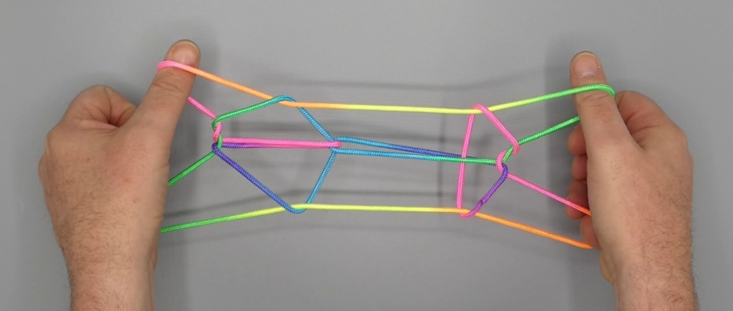

1. Position 1.
2. Pass R1 from above behind L palmar string and hook it up, passing R1 towards the body over TV 1n and up.
3. Pass L1 from above behind R palmar string and hook it up, passing L1 towards the body over R1 loop and up.
4. With 2 from above remove 5 loop.
5. Pass 5, under 2 loop, from below in double 1 loop close to 1, and hook down TV 2n through double L1 loop, closing 5 to the palm.
6. With 3 from below share 2 loop, pass 23 towards the body over intermediate strings and pinch TV 1n between tips of 23, 2 passing over, 3 under TV 1n. Turn 23 down away from the body over 1 loops through 2 loop (which slips off 23) and up, then separate 23.
7. Allow lower 1n (that continues to 2f on the same hand) to pass over upper 1n and off 1.
8. With R1 from below remove L1 loop, then with L1 from below share double R1 loop. With 1 pick up 2n, then Navajo 1, passing tips of 1 towards each other over upper 1n, then down towards the body under middle and lower 1n and up.
9. Release 2 loop and extend, palms facing each other, 1 pointing towards the body, 5 being crooked.

