MR48d. Kitikmeot 19

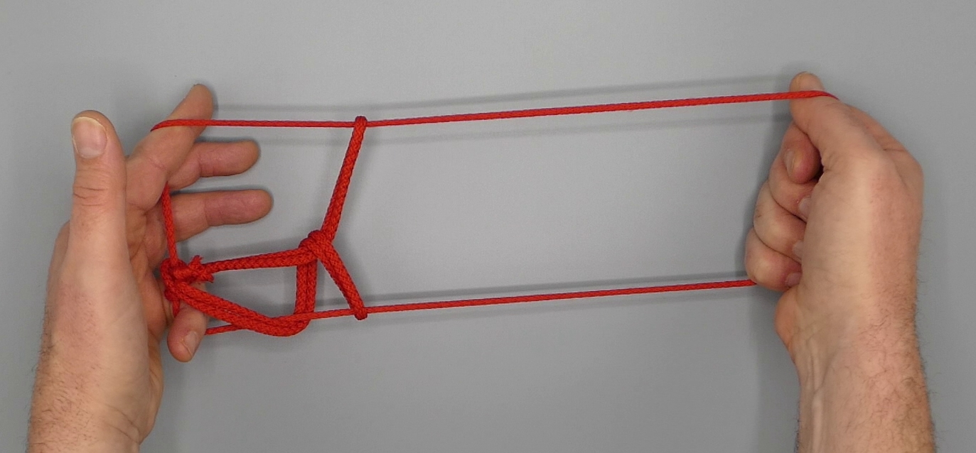

1. Hold about one quarter of string segment of an untwisted string loop between 123 of each hand, so that a pending loop hangs down between the hands. Toss the pending loop away from the body, then towards the body over the string segment. There are now three hanging loops in the string. The middle loop is slightly larger than the left and right loop.
2. With 2345 towards the body enter the loop held with 123, simultaneously releasing grip of 123. Bring RH away from the LH and drape middle loop over L thigh. Press middle loop between thighs.
3. Straighten L2, then with L2 from below remove R2345 loop.
4. Below the LH, hanging down from L2, an 8-like structure can be distinguished. With R2 hook the crossing of the 8-like structure by passing towards the left entering lower half of 8-like structure then towards the right entering upper half of 8-like structure and returning to the right.
5. With L1 from above remove loops held by L2, release grip of L345, then with L1 at the far side of the figure and from the left enter middle loop, releasing grip of thighs.
6. With R3 from below share R2 loop and extend, L1 pointing upwards, R23 pointing towards the floor. Twist hands to and fro around the wrists to adjust the figure until a hourglass-shaped figure appears between two TV strings.
7. With L5 from below enter L1 loops and hook down (upper) TV L1f through middle and lower L1 loops, closing L5 to the palm.
8. Pass L23 from above into L1 loops, pick up double oblique (middle and lower) L1n, carrying those oblique strings away, under (upper) TV L1n and up; between the fingertips of L2 and L3 trap TV L1n then rotate away from the body and up through the L1 loops.
9. Remove L1 from the figure. A double-walled diamond can be seen in the left half of the figure. At the right point of the diamond the upper right and lower right sides of the diamond are connected by a connecting string segment originating in R23n and R23f. Pass L1 from below in L2 loop close to L2, move it to the right along the near side of the connecting string segment, then from the right with L1 hook the connecting string segment (exactly between the upper right and lower right sides of the diamond) in its bend; return L1 through L2 loop.
10. With R1, at the near side of the figure, from below remove L1 loop. Remove R23 from the figure.
11. Return R1, and upon returning introduce a ¾ twist in its loop in a clockwise direction (when looking at tip of R1) by turning R1 towards the body, down and away from the body.
12. With R2345 from above share R1 loop to enlarge it. Extend, L2 pointing away from the body and up, L5 being crooked.

