p16
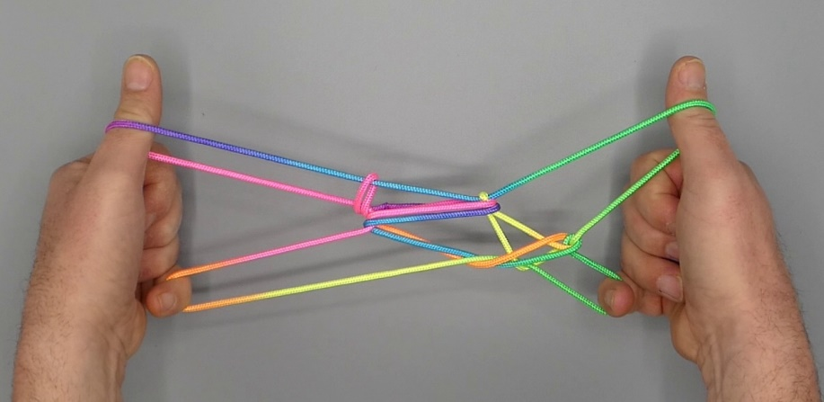
Made by Peter Apiana

1. Position 1.
2. Pass R1 over L5f and hook it up, passing R1 towards the body (over L1n) and up.
3. With L1, over L5f, pick up R5f and return.
4. Release 5 loop.
5. Pass 5 from below in double 1 loop, then pass it away from the body over the 1f that runs to 1n on the other hand, under TV 1f and up, then with 5 hook down TV 1f, closing 5 to the palm.
6. Pass 23 from above in 1 loops, towards the body under upper (non-TV) 1n, then pinch lower (TV) 1n between tips of 23 (2 passing over, 3 under the string); turn 23 down away from the body under upper 1n and up, then separate 2 and 3.
7. Remove 1 from the figure and extend, palms pointing towards each other, 2 pointing away and up, 5 being crooked. A two-diamond figure is formed.
8. With R1, from the center, pick up upper right s ide of right diamond, and with L1, from the center, pick up upper left side of left diamond.
9. With R1 from below remove L1 loop, then with L1 from below share double R1 loop. With 1 pick up 2n close to 2, then Navajo 1 by bending 1 over upper 1n, down towards the body under middle and lower 1n and up. Remove 2 from the figure.

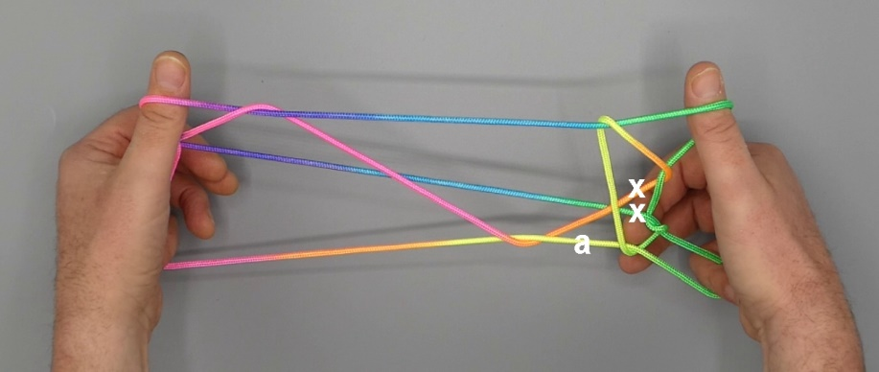

10. Hold figure with palms facing each other, 1 pointing away and up, 5 being crooked. Pass R2 at the far side of the figure from below behind the two strings marked “x” in the photograph, then from above through R1 loop, along the near side of the figure from above behind string marked “b” in the photograph, and hook this string marked “a” in its bend and return through R1 and under strings marked “x”.
11. Pass R2 with its loop from above through R1 loop so that its loop is below original R1 loop, gently release L5 then pass L5 under L1 loop at the near side of the figure towards R2 and with L5 (its tip pointing towards tip of R2) from above remove R2 loop, closing L5 to the palm. Return R2.
12. Extend, palms pointing towards each other, 1 pointing up and away, 5 being crooked.

13. Dissolve the figure by entering 2 from above in 1 loop in the middle between the hands (between the “legs” of the upside down animal), removing 1 and 5 from the figure and separating hands.

