P33
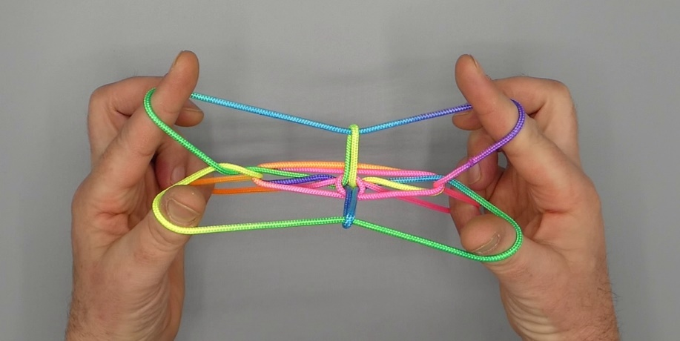

Martha Angulalik

1. Opening A.
2. With 1, under 2n, pick up 2f and return under 2n.
3. Release 2 loop.
4. With 1 from below remove 5 loop, and keep loops on 1 well separated.
5. With 5 from below enter lower and middle 1 loop, then pass 5 to the far side of upper (TV) 1f, and hook down upper 1f through middle and lower 1f, closing 5 to the palm.
6. Pass 23 towards the body, over triple 1f, over upper and middle 1n, then pinch TV lower 1n between 23, 2 passing at the near, 3 at the far side. Pass 23 to the far side over middle and upper 1n, then with 2 pick up middle and upper 1n, raising 2 and lifting middle and upper 1n off 1. Make sure to maintain the lower 1n on 1 (should it have dropped off 1, pick it up again). Remove 3 from the figure.
7. With R1 from below remove L1 loop, then with L1 from below share double R1 loop. Pass 1 over all intermediate strings under double 2f and pick up double 2f, then return, and Navajo 1 by bending tips of 1 towards each other over double upper 1n, towards the body under double lower 1n and up. Release double 2 loop.
8. On each of the double 1n is, in the middle between the hands, a vertical lozenge. Pass 2 towards the body between double 1n separating them into parallel strings with a vertical lozenge on each. With 2 lift the string on its back off of 1. There should now be a vertical lozenge on 1n and 2f.
9. Extend, separating 1 and 2 of each hand, 5 being crooked.

