xMR48c. Kitikmeot 06. Tiriganniaq (fox)
Informant: Susie Apiana

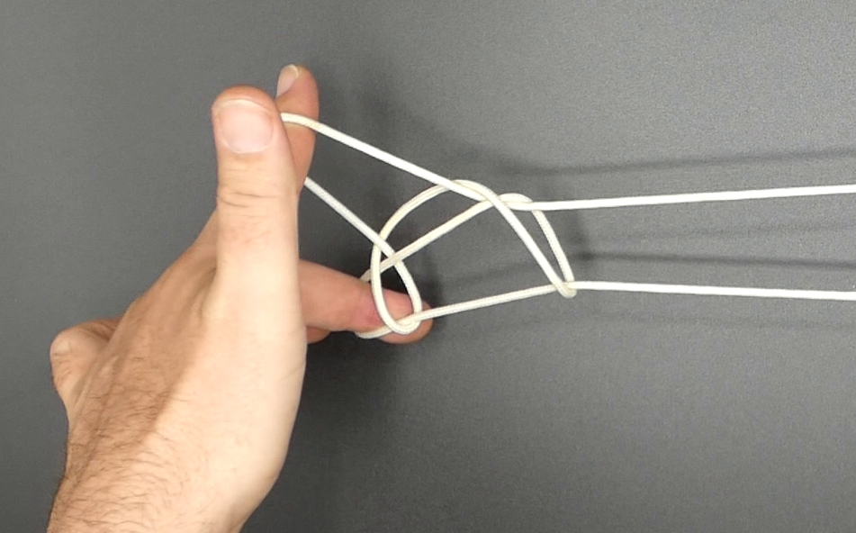

1. Opening A.
2. Pass L34 from above in L5 loop then pass them towards the body under L2 loop and from the far side pinch L1f between L34, L3 passing over, L4 under L1f. Return L34, passing L34 down, away from the body under 2 loop through L5 loop and up. Separate L34.
3. Pass R3 from below in R2 loop then over R2n, and from the far side pinch R1f between R23, R2 passing over, R3 under R1f. Return R23, passing R23 away from the body through R2 loop (which slips off) and away from the body.
4. Turn palms outwards, allowing 1 loop to slip off 1 and releasing 5 loop.
5. With R3 from above (= towards the body) enter the loop running from R23 to the LH, at the same time releasing grip of R23; keep R3 pointing towards the body. Separate hands, then with R1 from above (= away from the body) share R3 loop and lift R3n to enlarge the loop.
6. Extend, palms facing each other, R1 and L23 pointing away from the body, R3 pointing towards the body.

